**7-1-9 SUPPORTING DOCUMENTS**

FLAG DAY ➢ On 07.12.2023 To honour the martyrs and men in uniform who fights in borders to safeguard the country’s honour we cadets from SNMV CAS attend the celebration at collector office. F/C Yogalakshmi, F/C Ranjani, F/C Hemalatha attended the celebration. Dr G.S Sameeran IAS, Coimbatore District Collector were present.

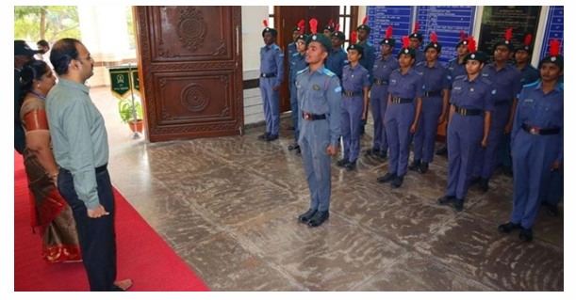

**ADVANCE LEADERSHIP CAMP (ALC)**

F/C Sowparnika attended ALC (Advance Leadership Camp) at Hindusthan College of Engineering & Technology from 03.01.2023 to 12.01.2023 conducted by 2 TN Artillery Battery NCC, Coimbatore.

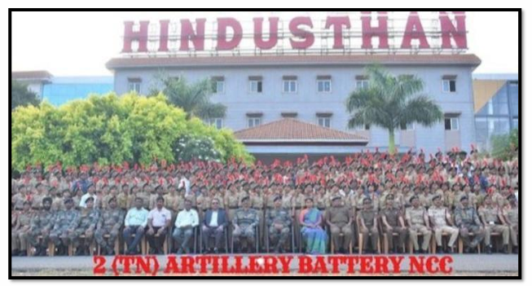

**PUNEET SAGAR ABHIYAN**

On 11.02.2023, 2 TN AIR SQN NCC organized Puneet Sagar Abhiyan at Sungam Valankulam lake, Coimbatore. NCC cadets removed all the plastics from the water bodies. 09 of Our NCC cadets participated in the event. Fg Offr. T. Purushothaman, ANO participated in the event.

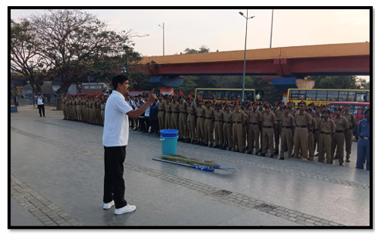

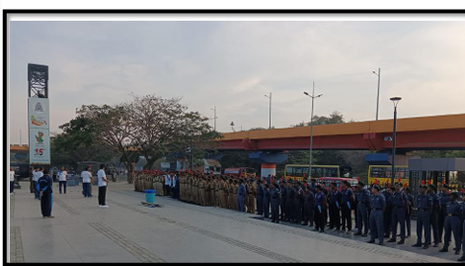

**DEFENCE CAREER EXPO 2023 ➢On 01.03.2023**

Defence Career Expo 2023 held at Kumaraguru College of Engineering. 10 of our NCC cadets participated in the expo.

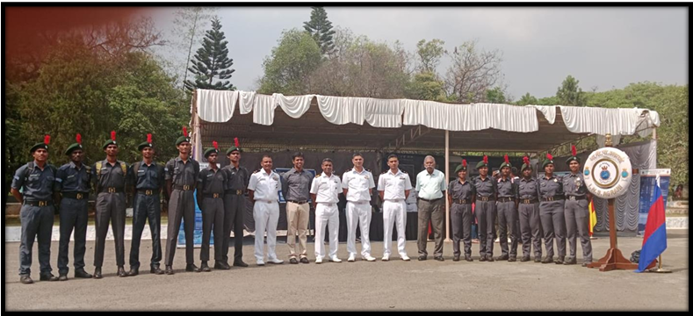

**INDEPENDENCE DAY CELEBRATIONS**

On 15.08.2023 We celebrated 77th Independence Day Group Captain Sriram S, Senior Education Officer, Air Force Station, Sulur was the Chief Guest & Flight Lieutenant Yugala, Meteorology Officer, Air Force Station, Sulur was the Guest of Honour.

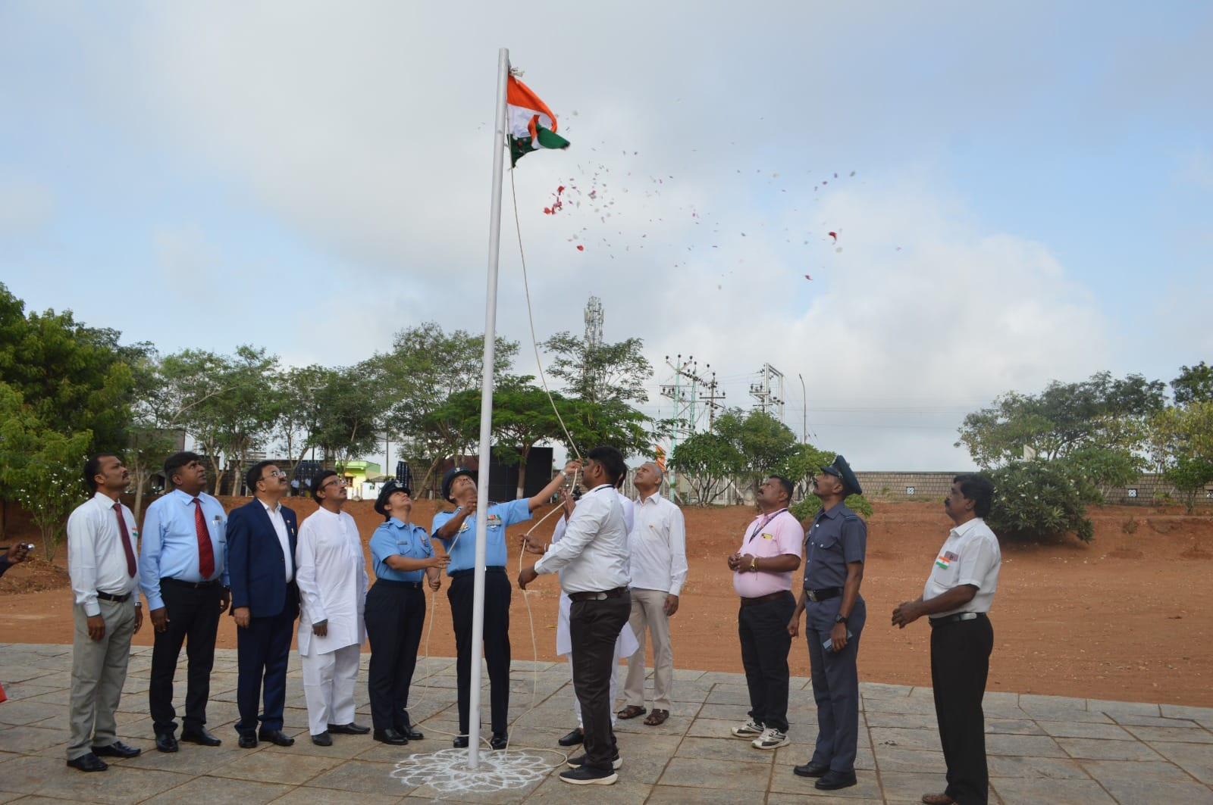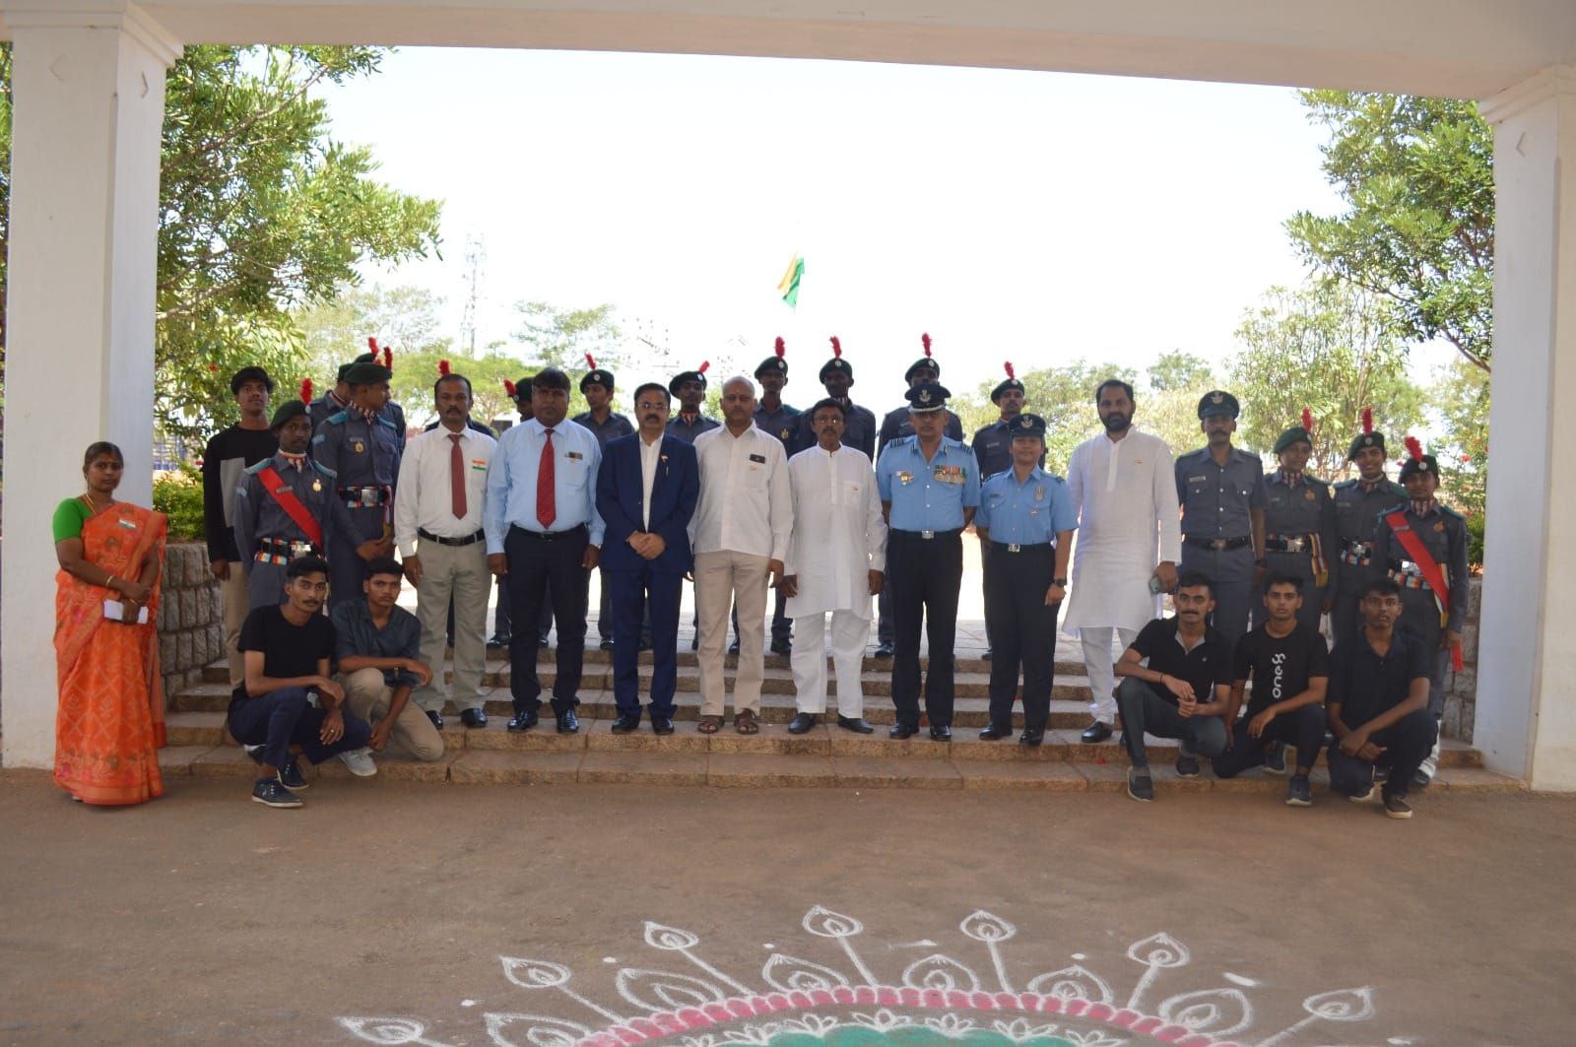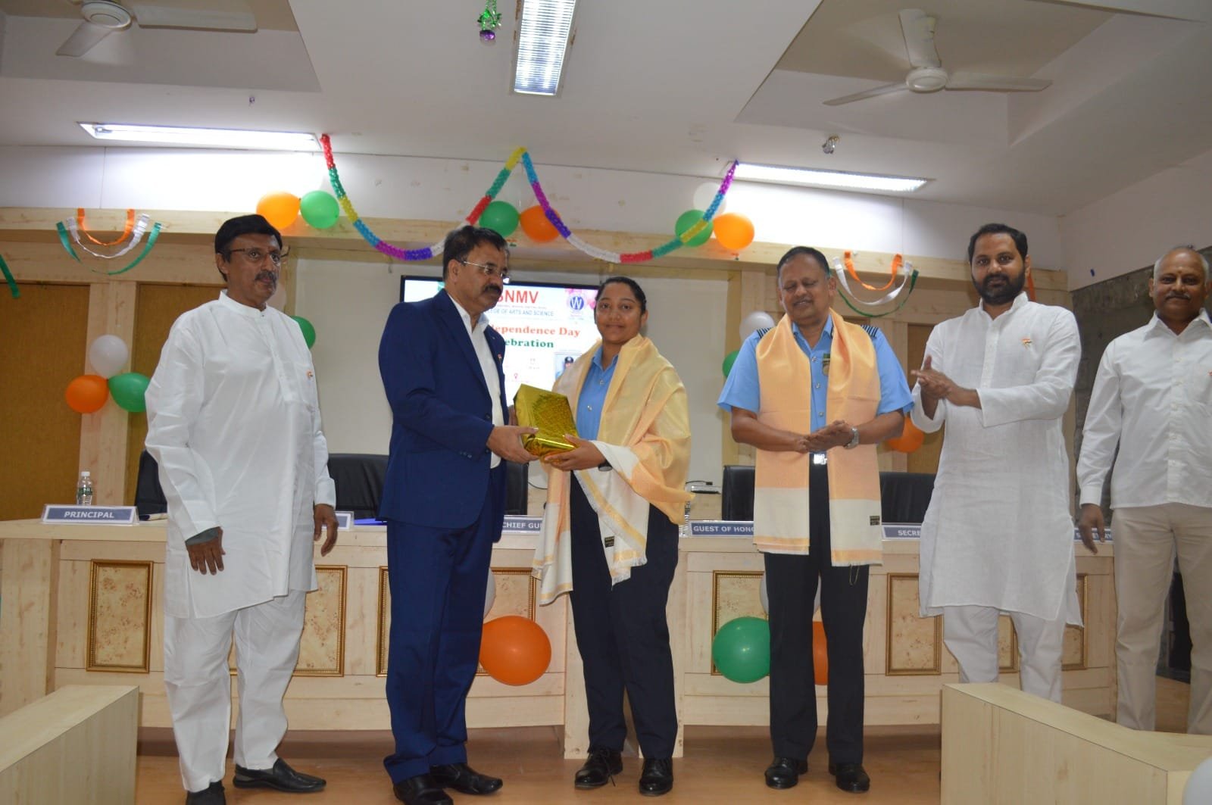

**REPUBLIC DAY CELEBRATION**

