**7-1-9 ANY OTHER RELEVANT**

**REPORT - AWARENESS PROGRAMME ON ANTI-SMOKING AND DRUG ABUSE**

Youth Red Cross (YRC) in collaboration with Department of Public Health and Preventive Medicines Organized Awareness Programme on “Anti-Smoking and Drug Abuse” on 16.08.2023. Welcome address was delivered by Mr. P. Karthi, YRC Program Officer. Then the event is presided over by Dr. B. Subramani, Principal of SNMV college of Arts and Science. Chief guest of this event was Mr. K. Muralikrishnan, Social Worker, District Tobacco Control Cell, Department of Public Health, Coimbatore. He gave the graphic example of tobacco awareness and interacted with students along with statistical methods to avoid using tobacco.

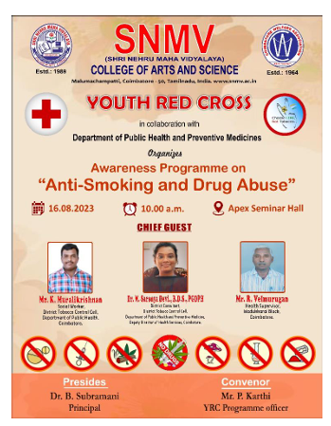

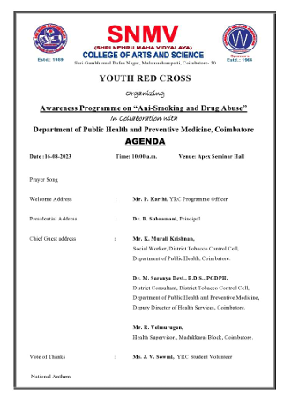

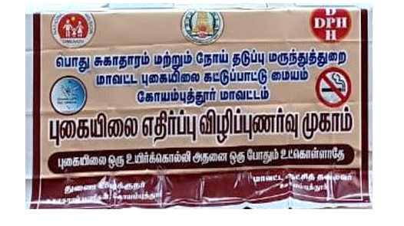

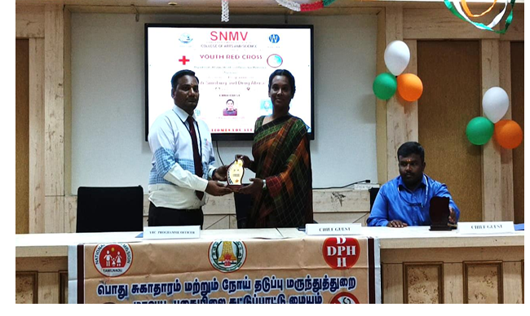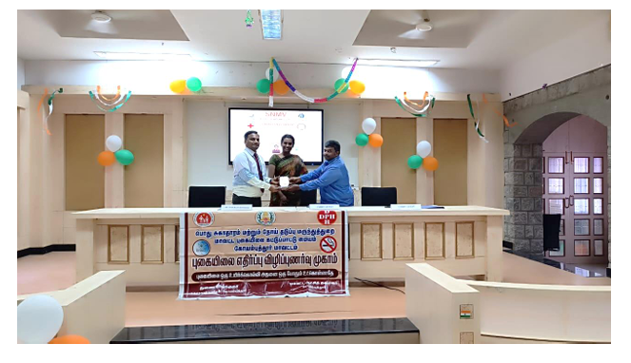

**REPORT - AWARENESS PROGRAM ON HEALTH AND HYGIENE FOR GIRL STUDENTS**

Youth Red Cross in association with Department of Commerce with Corporate Secretaryship organized an awareness program on “Health & Hygiene for Girl Students” at Mahaveer’s auditorium on 05.10.2023. Welcome address was delivered by Mr. P. Karthi, YRC Program Officer. Then the event is presided over by Dr. V. Padmanabhan, Dean - Commerce of SNMV college of Arts and Science. Dr. G. S.Sharmila, Associate Professor & Medical Officer Dept of Biochemistry & Nutrition, JSSINYS, Coimbatore was the resource person she addressed the girl students about health & hygiene. Particular mudras of yoga have been taught for the benefit of their wellbeing**.**

