ANNUAL REPORT OF THE CELEBRATIONS FOR THE ACADEMIC YEAR 2023-2024

1.WORLD NO TOBACCO DAY
2. WORLD ENVIRONMENT DAY
3.WORLD DAY AGAINST CHILD LABOUR
4.INTERNATIONAL DAY AGAINST DRUGS ABUSE AND ILLICIT TRAFICKING
5.ANTI DRUG AWARENESS
6.NATIONAL GIRL CHILD DAY
7. WORLD WATER DAY AWARENESS SEMINAR
8.GANDHI JAYANTHI
9.INDEPENDENCE DAY
10.INTERNATIONAL DRUG ABUSE DAY
11.INTERNATIONAL WOMENS DAY
12.OZONE DAY
13.REPUBLIC DAY
14. TEACHERS DAY
15.ZERO DAY
16.NSS DAY

WORLD NO TOBACCO DAY
DATE:31.05.2023
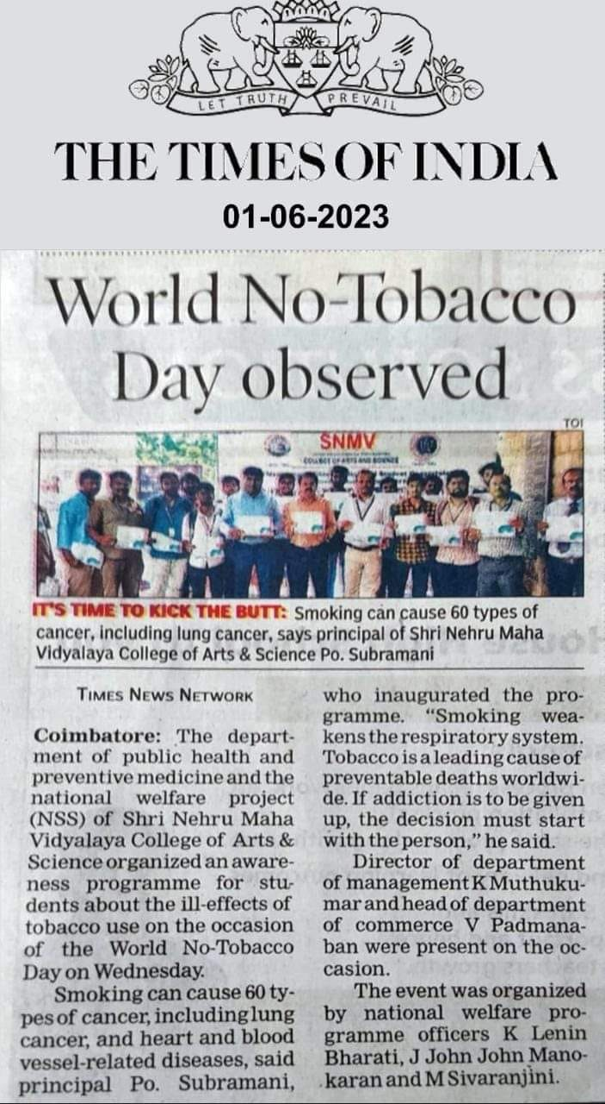

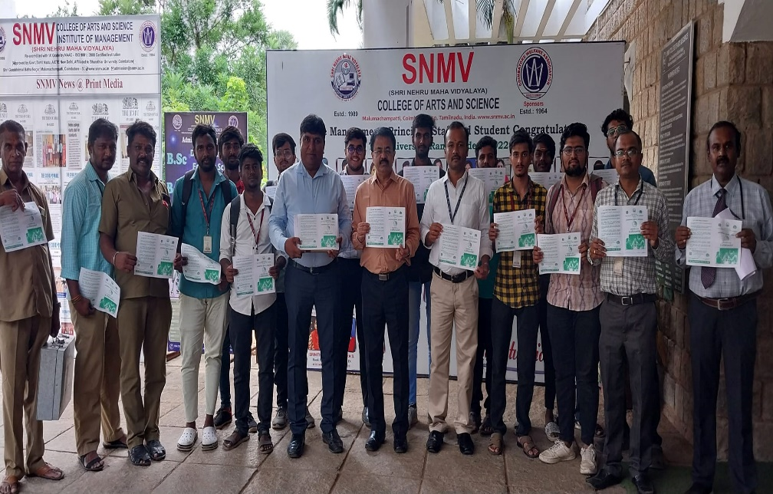

WORLD ENVIRONMENT DAY
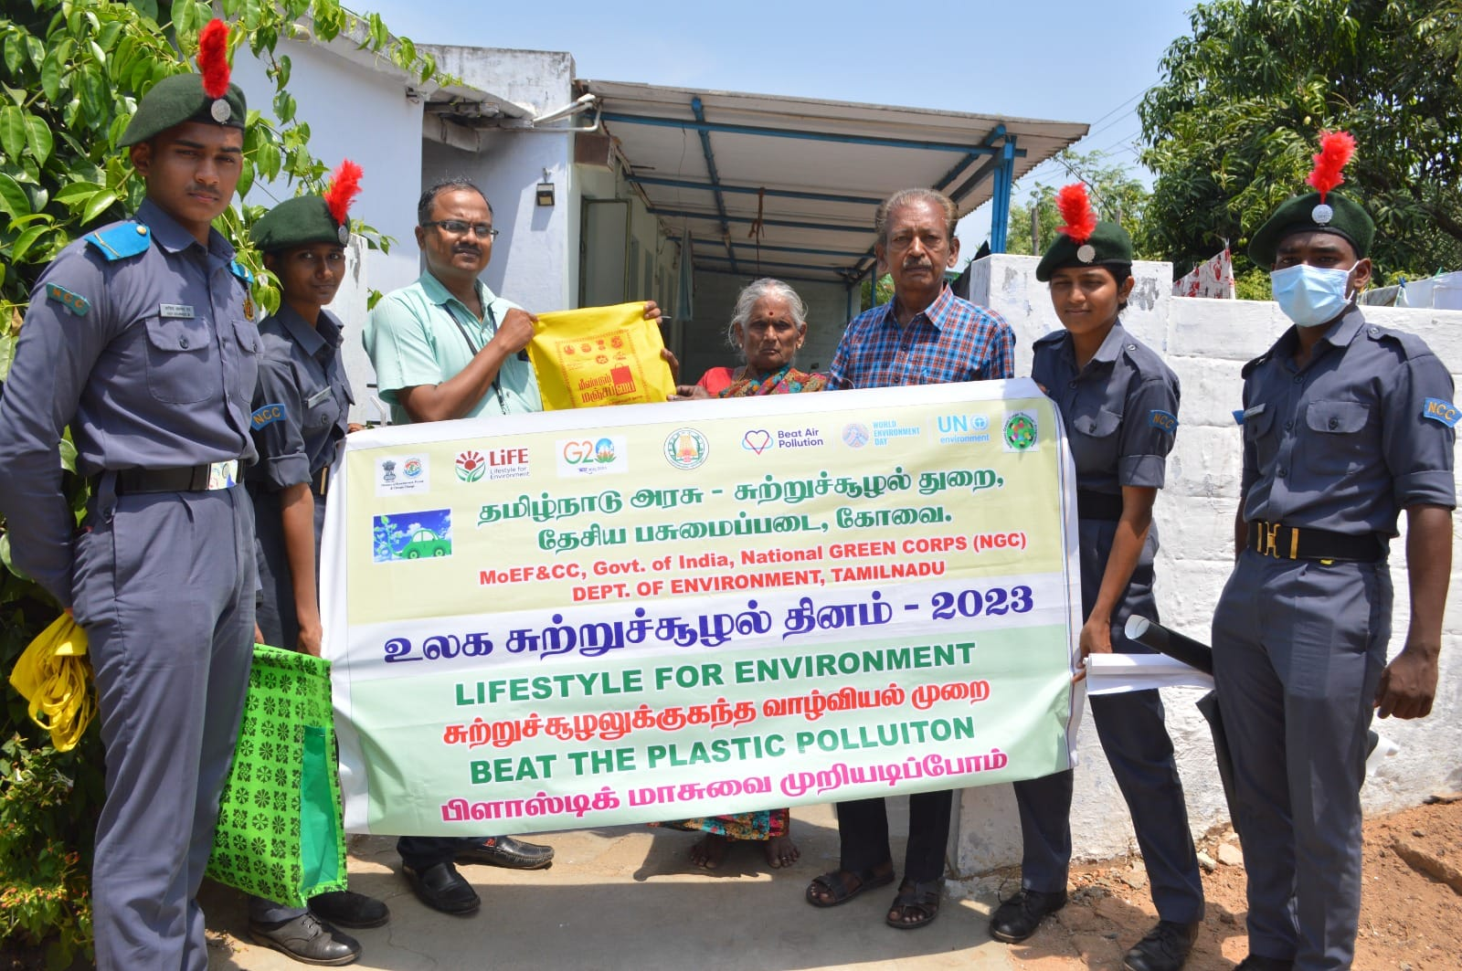
DATE:05.06.2023
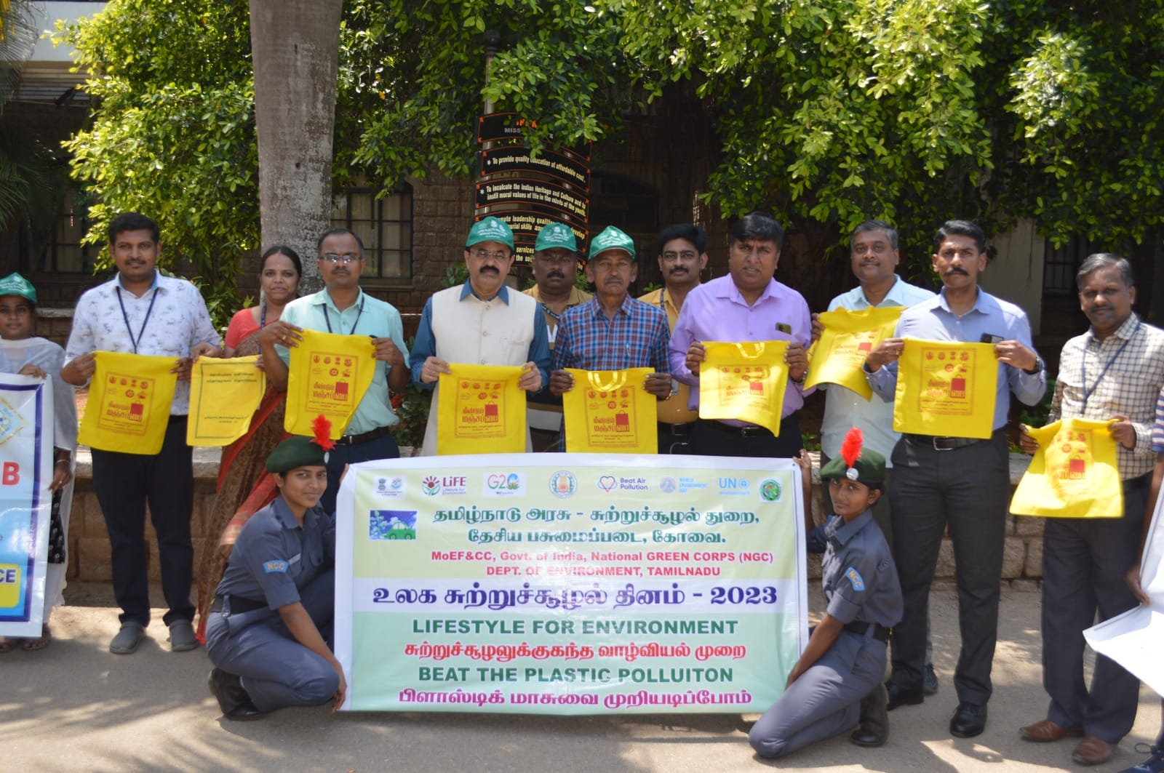

WORLD DAY AGAINST CHILD LABOUR (DATE:13.06.2023)
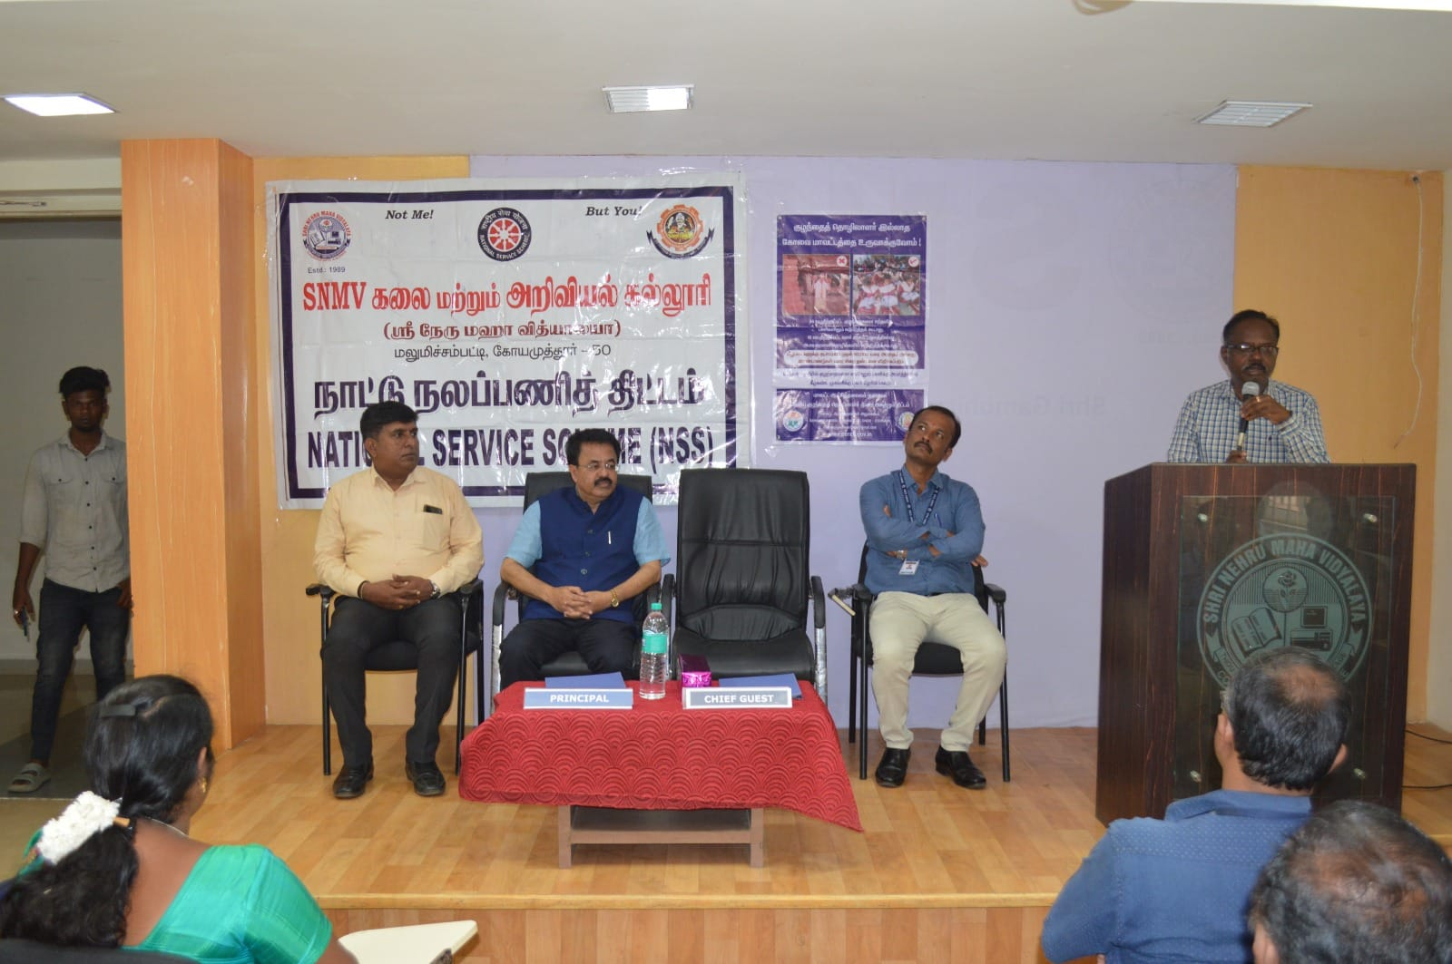
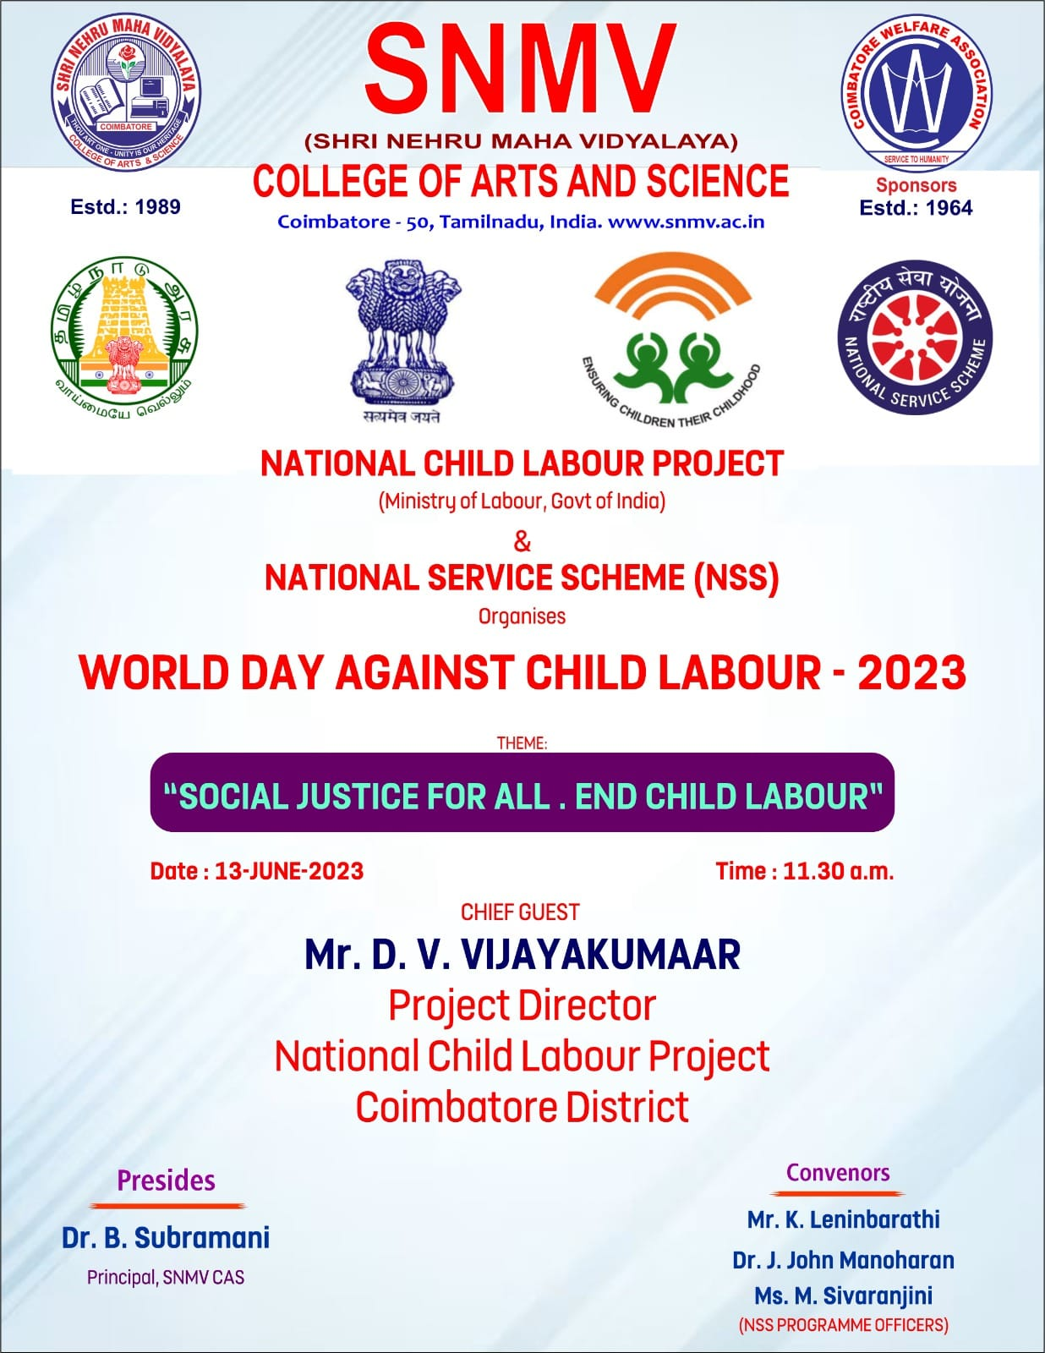

INTERNATIONAL DAY AGAINST DRUGS ABUSE AND ILLICIT TRAFICKING
DATE:26.06.2023

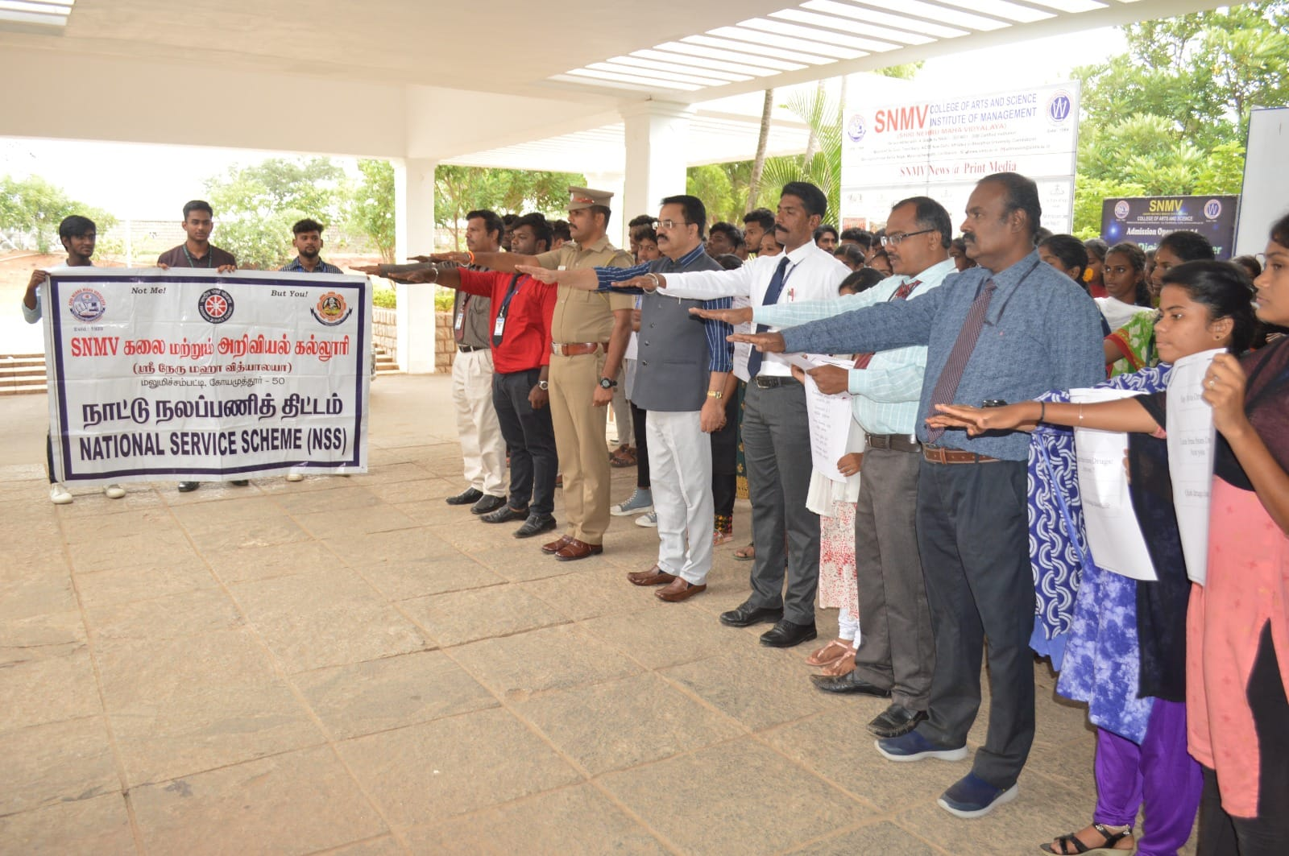
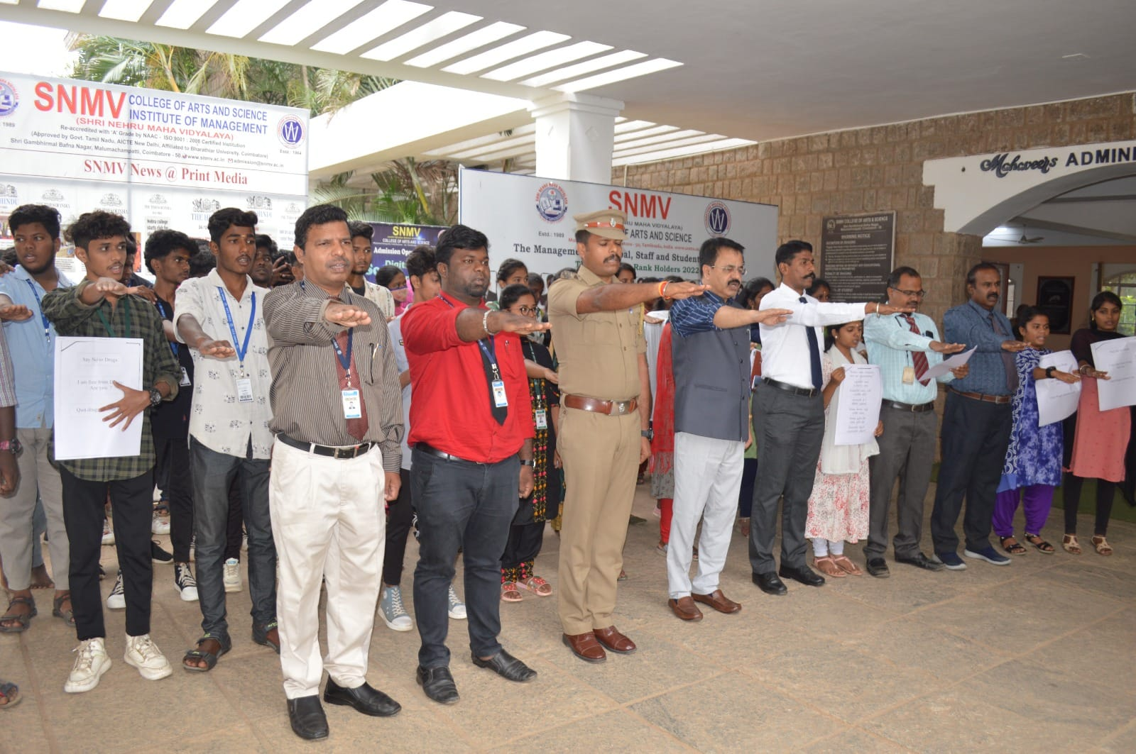

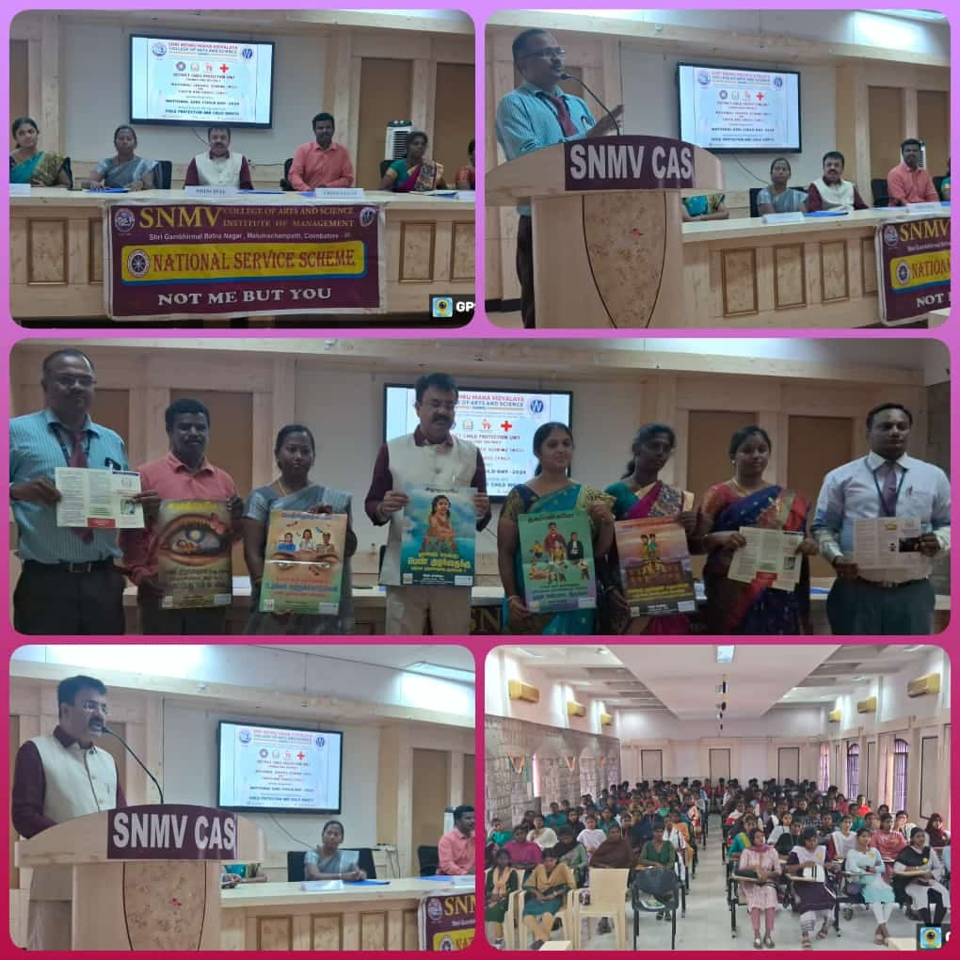
NATIONAL GIRL CHILD DAY -SEMINAR DATE: 24.01.2024

WORLD WATER DAY AWARENESS SEMINAR
DATE:22.03.2024
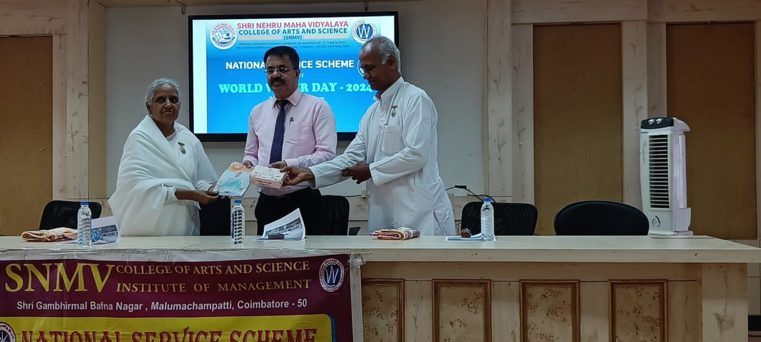

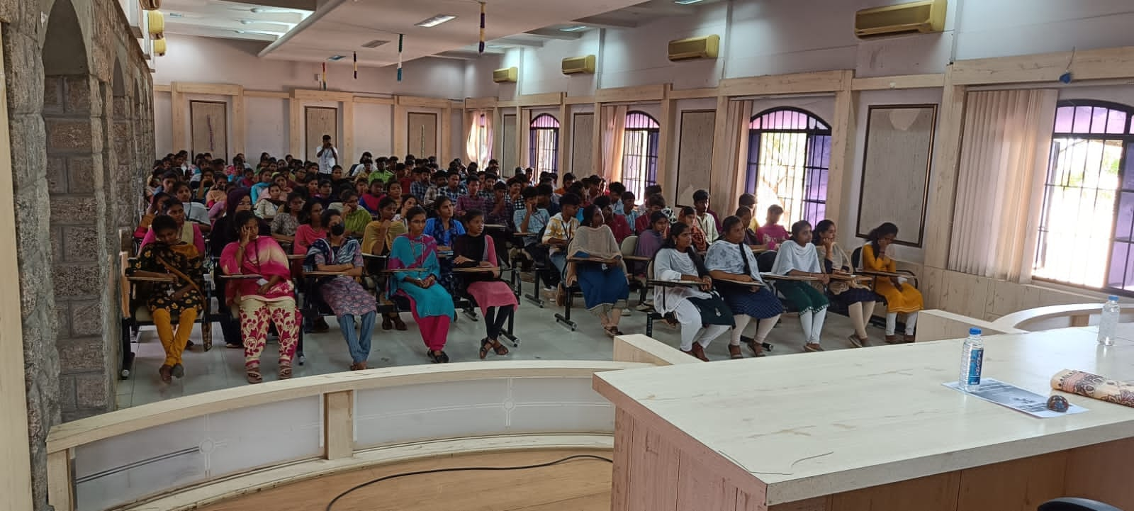

GANDHI JAYANTHI
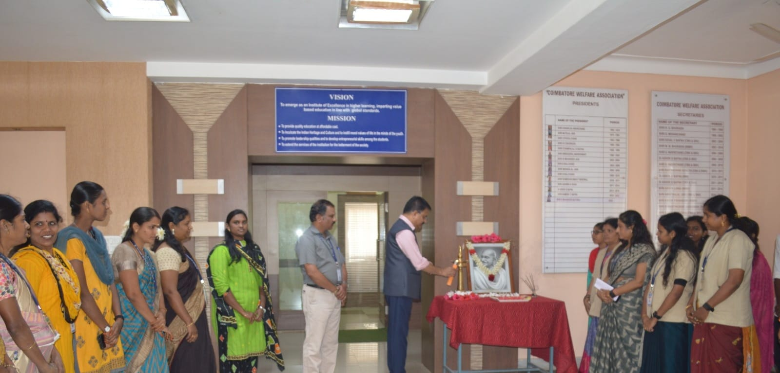
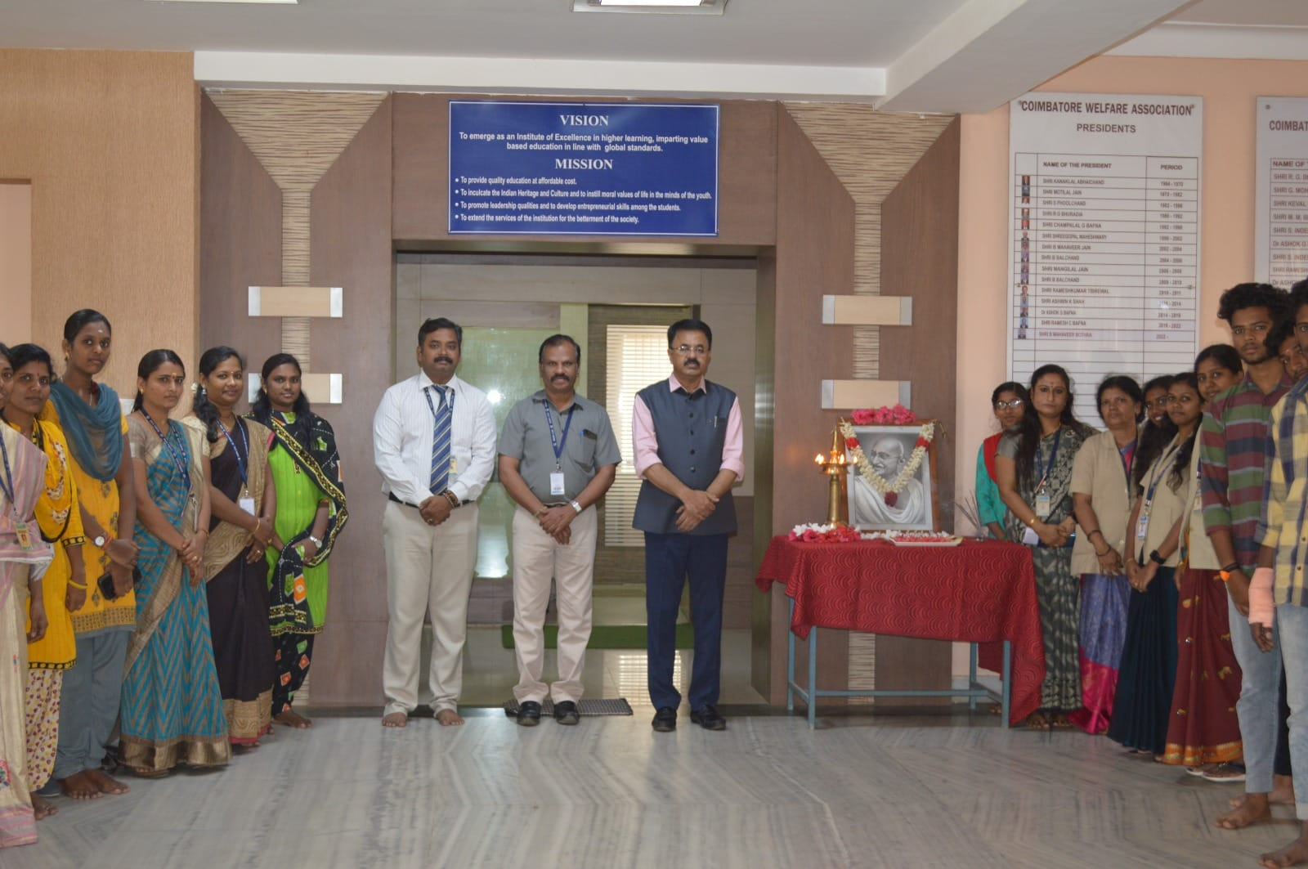

INDEPENDENCE DAY
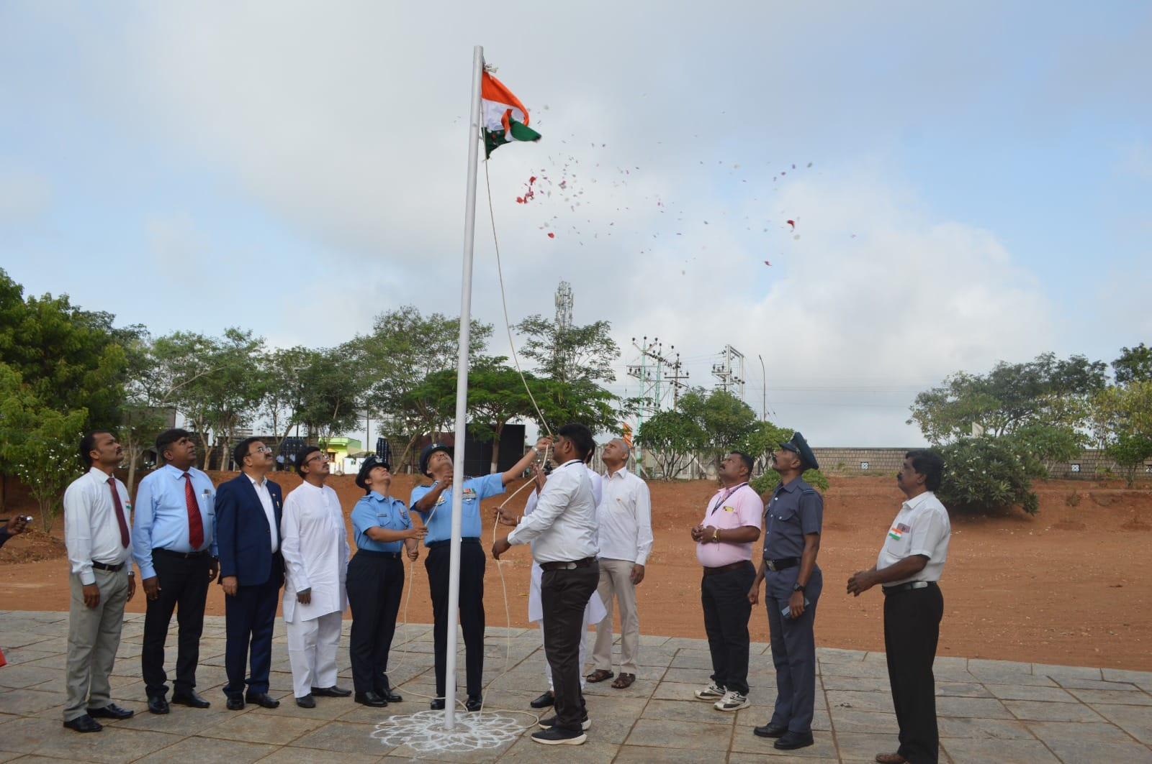

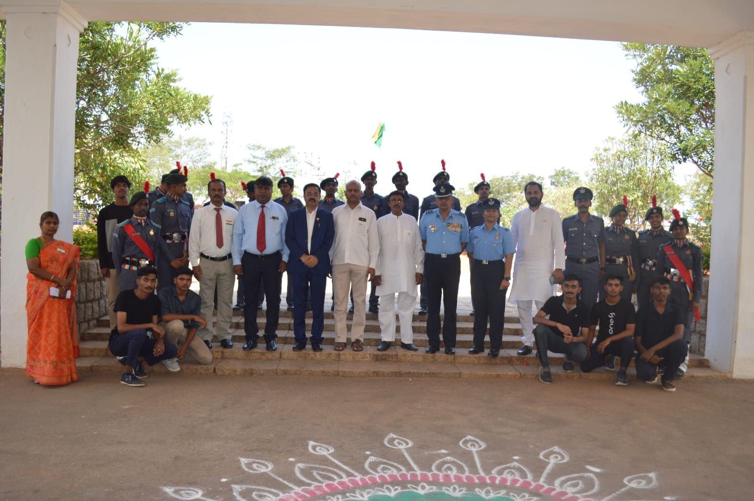
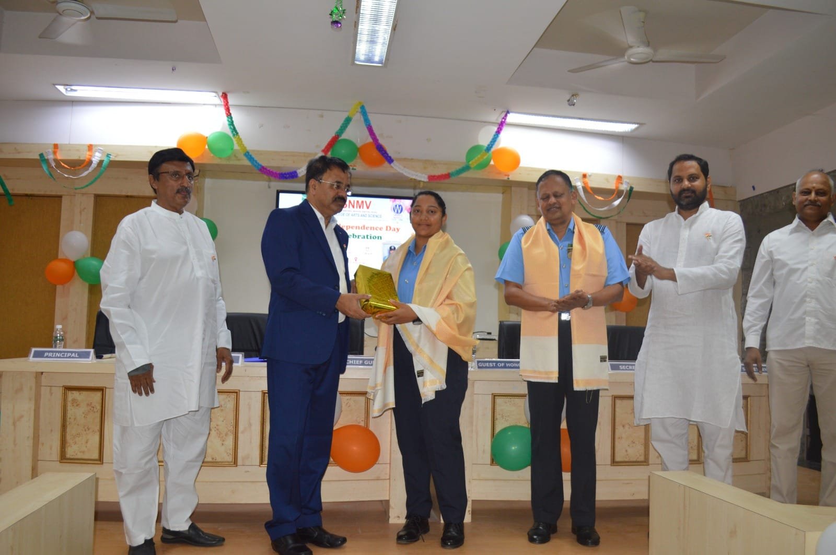

INTERNATIONAL WOMEN DAY
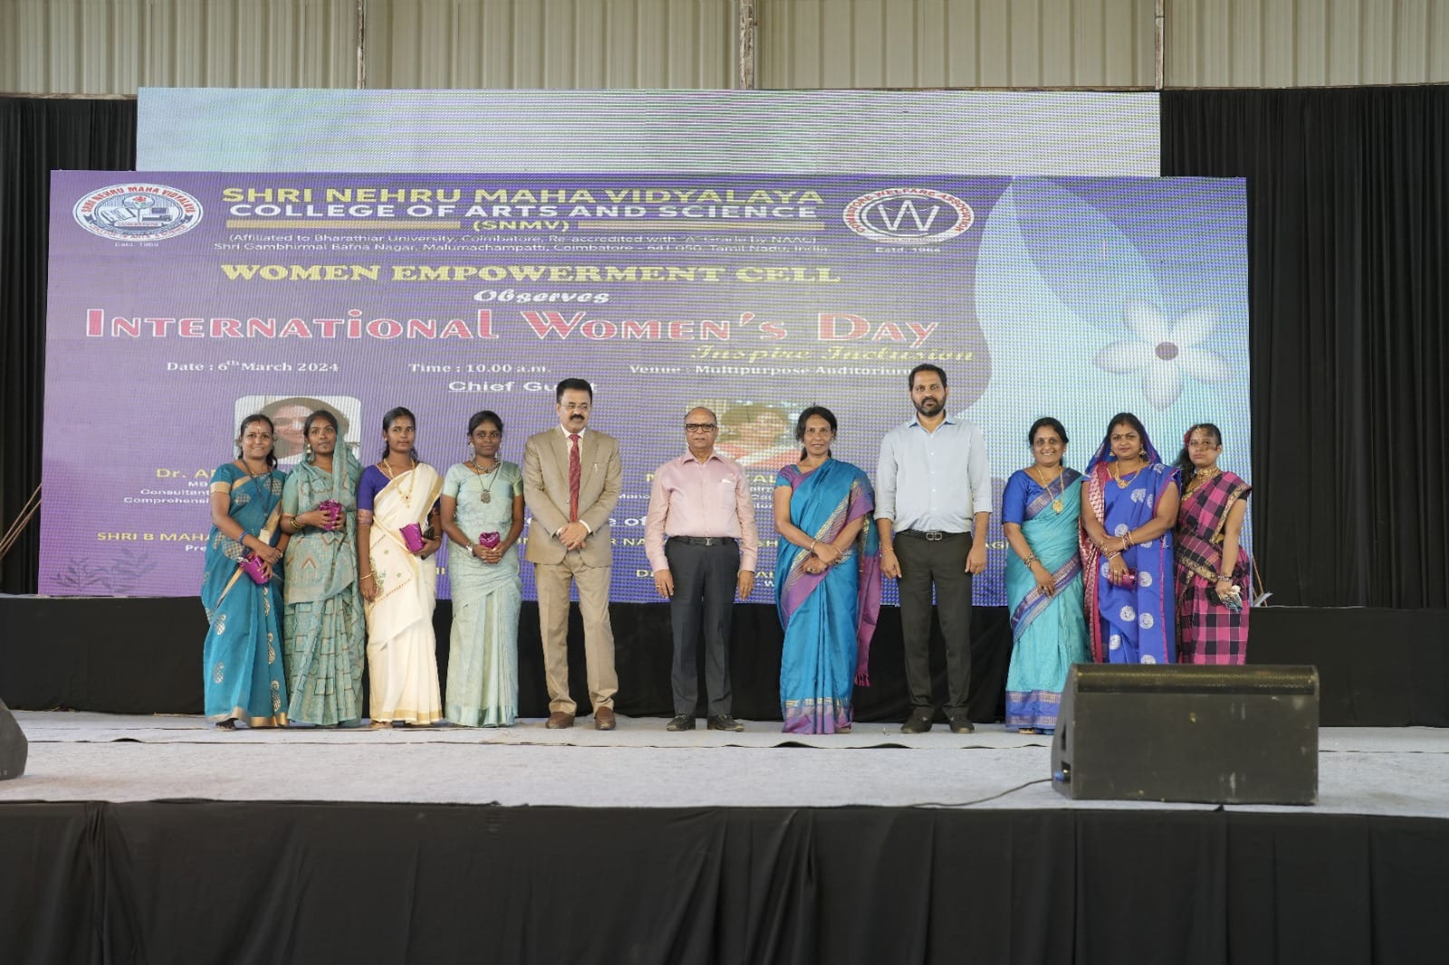

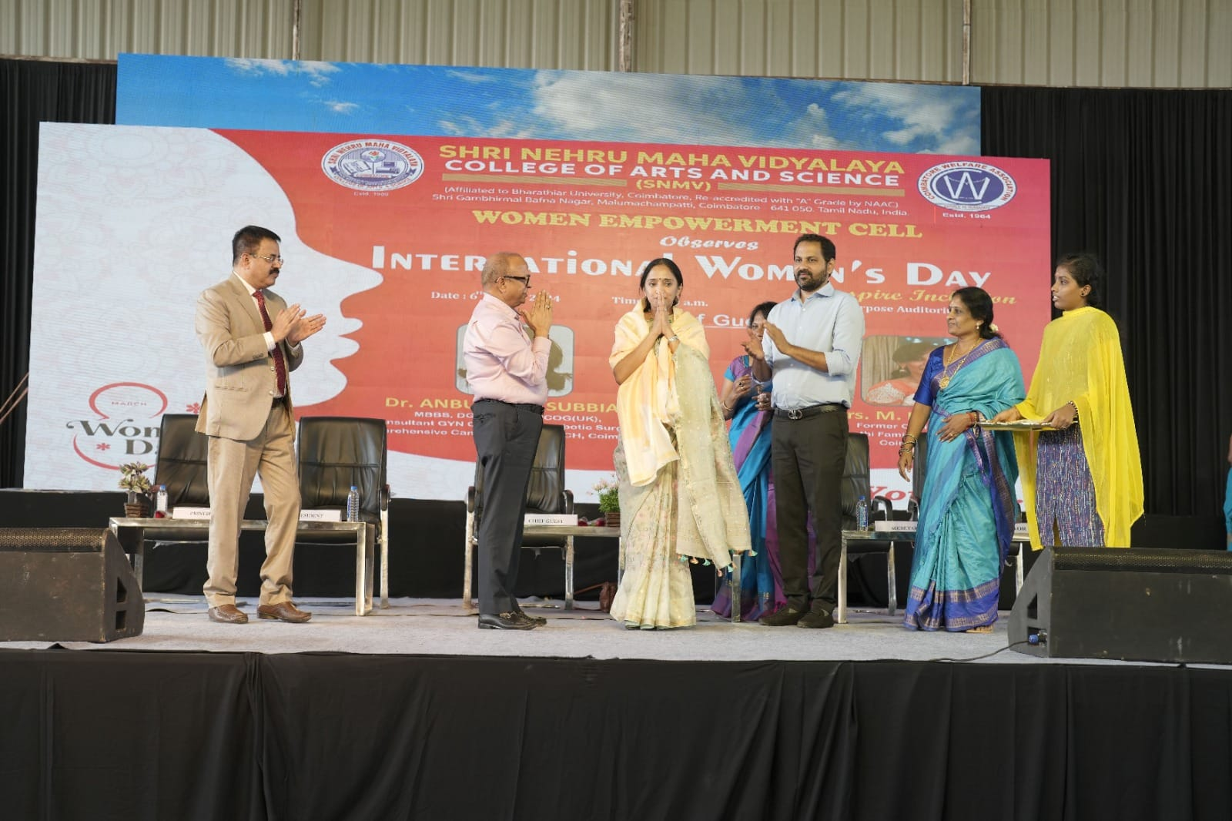
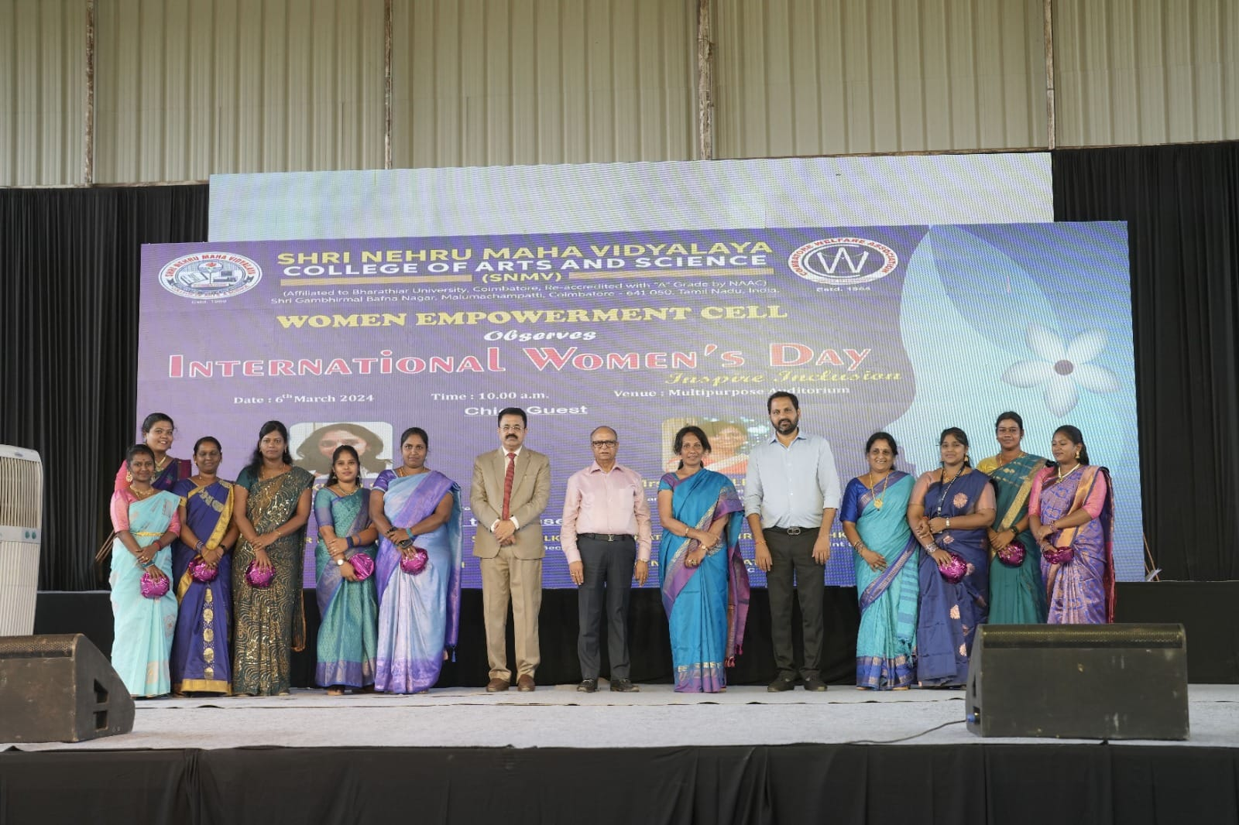
INTERNATIONAL YOGA DAY
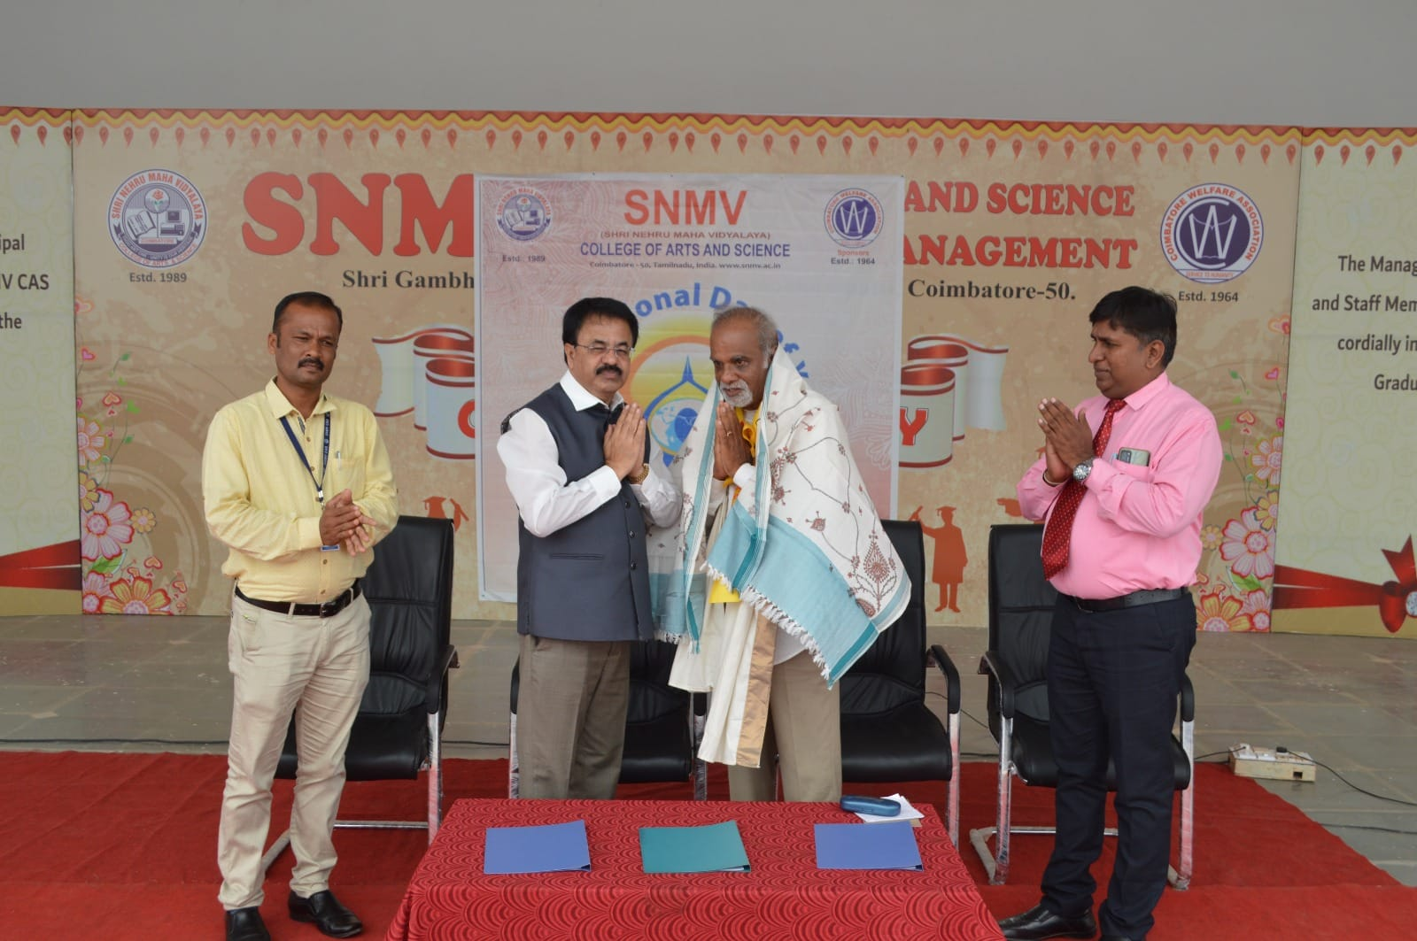

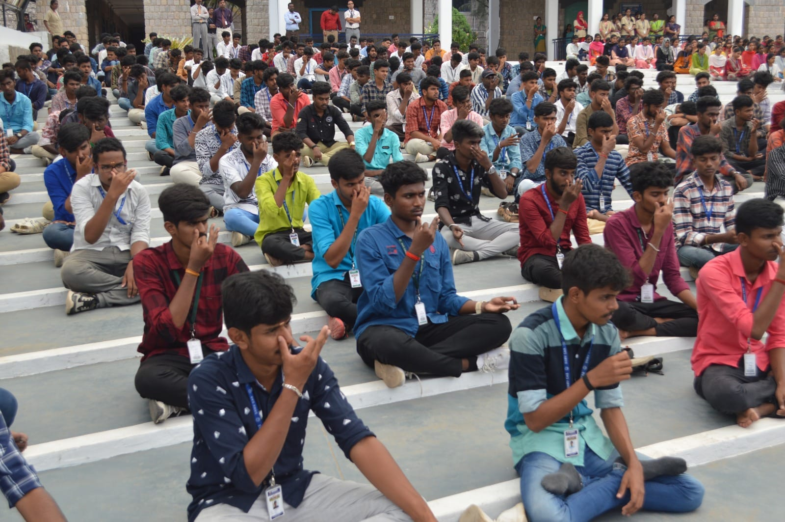
NSS DAY
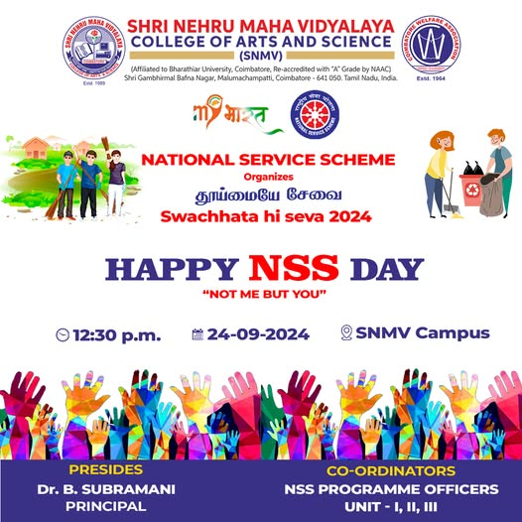

OZONE DAY
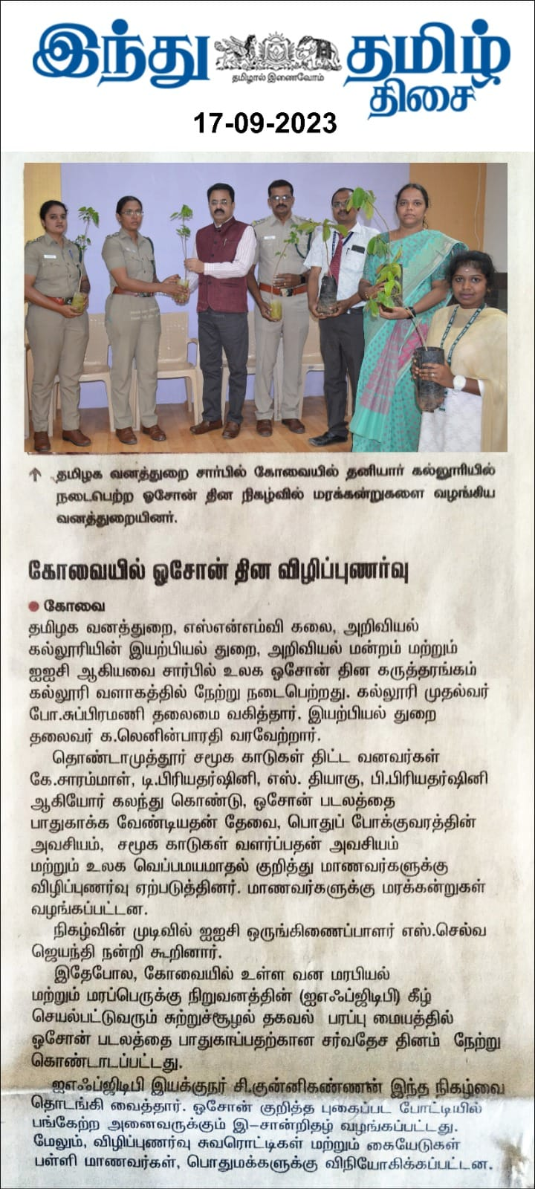
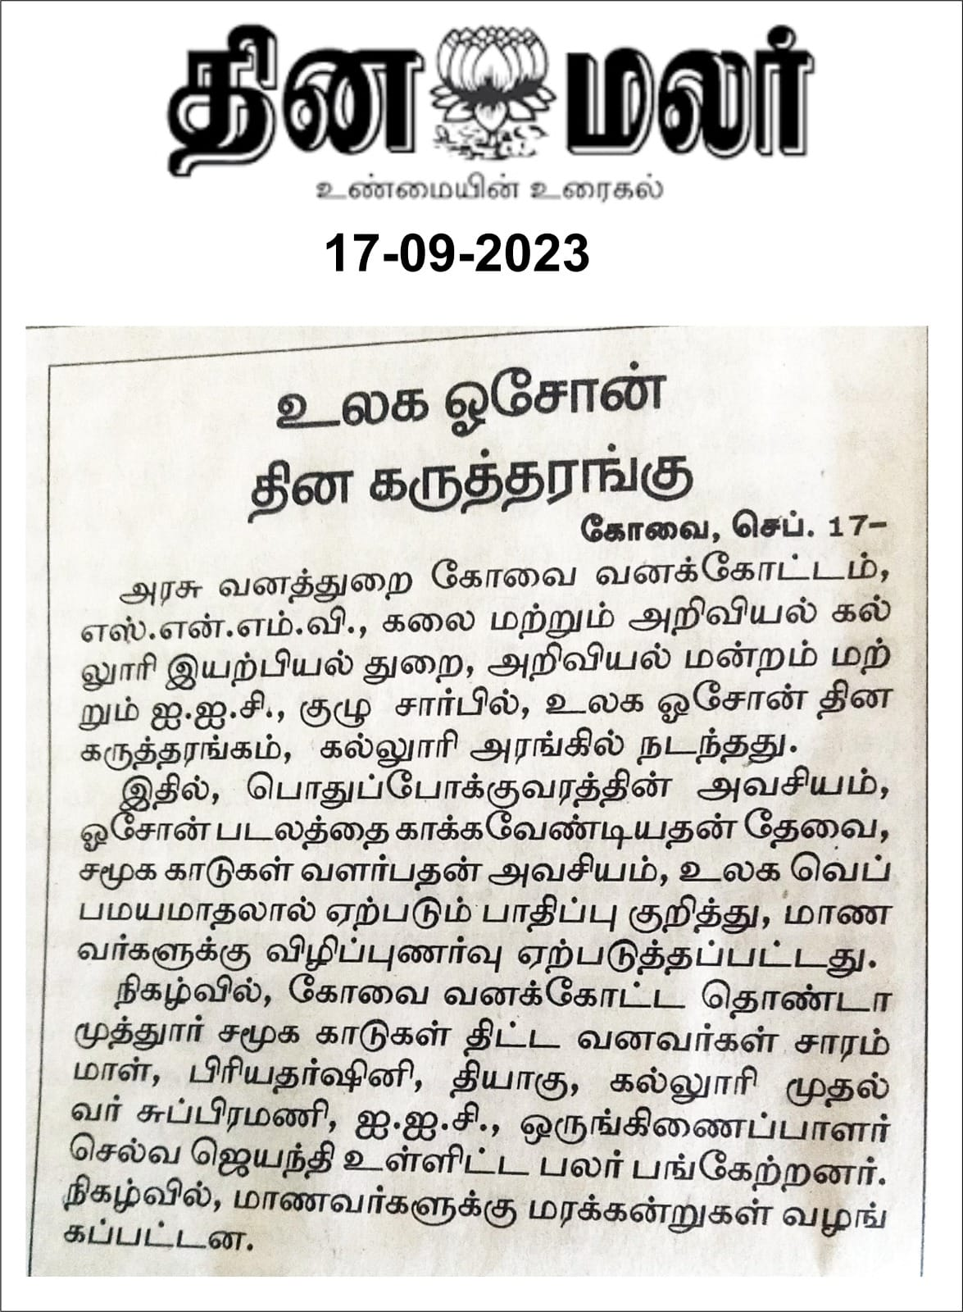
REPUBLIC DAY
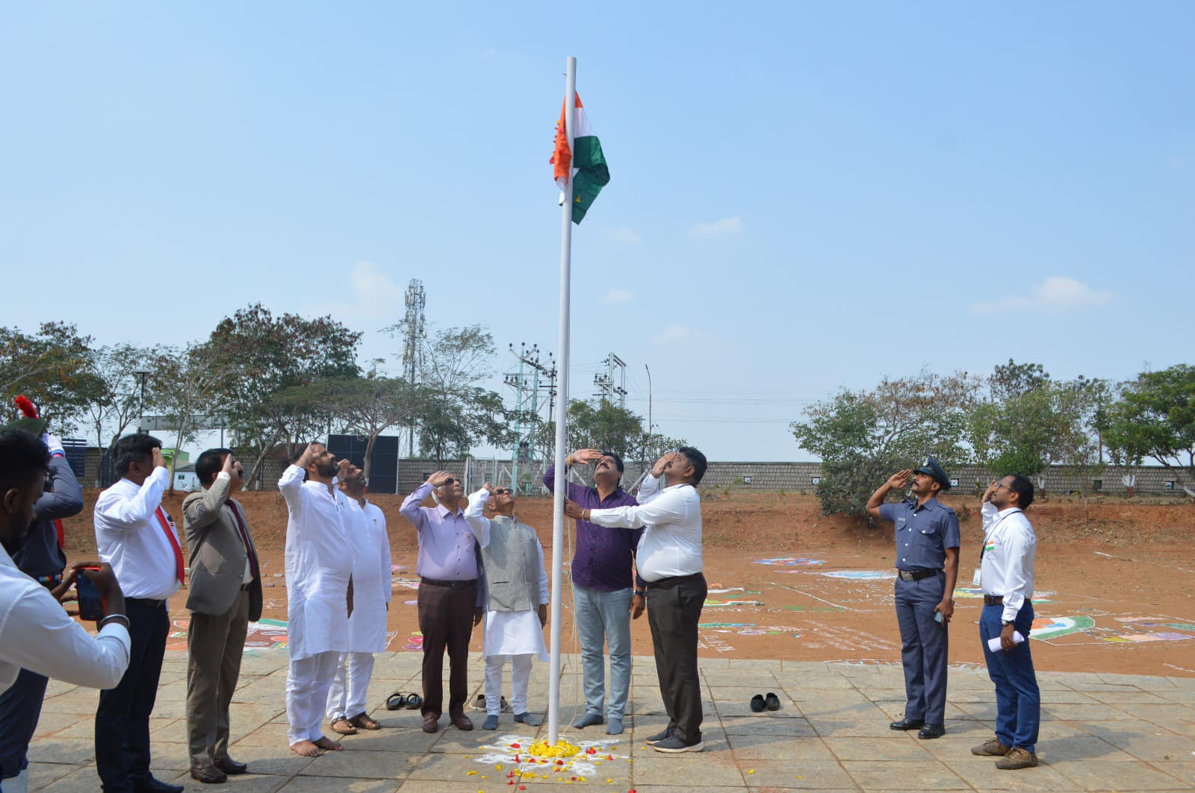
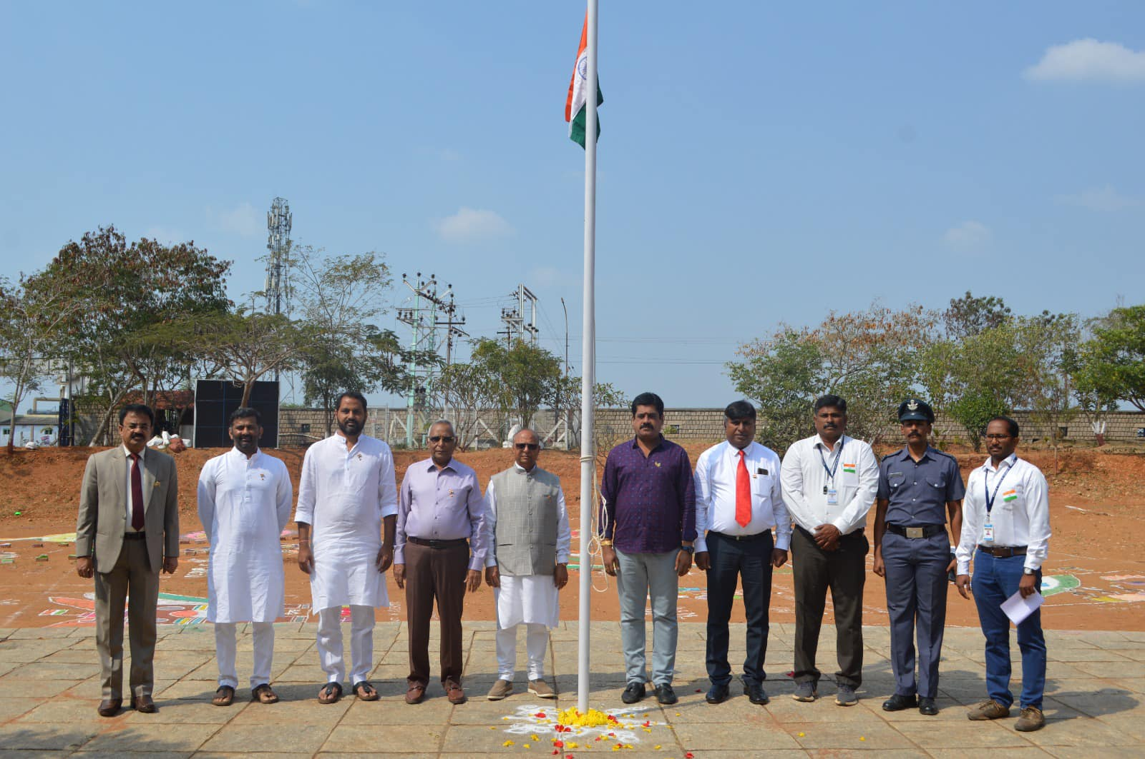
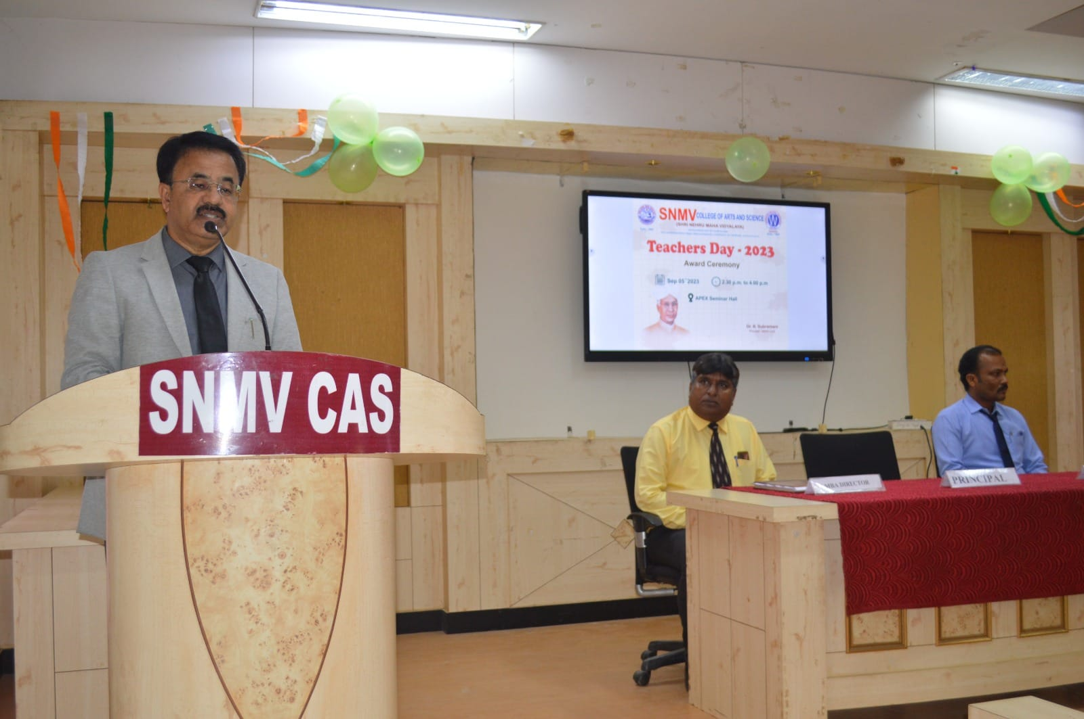
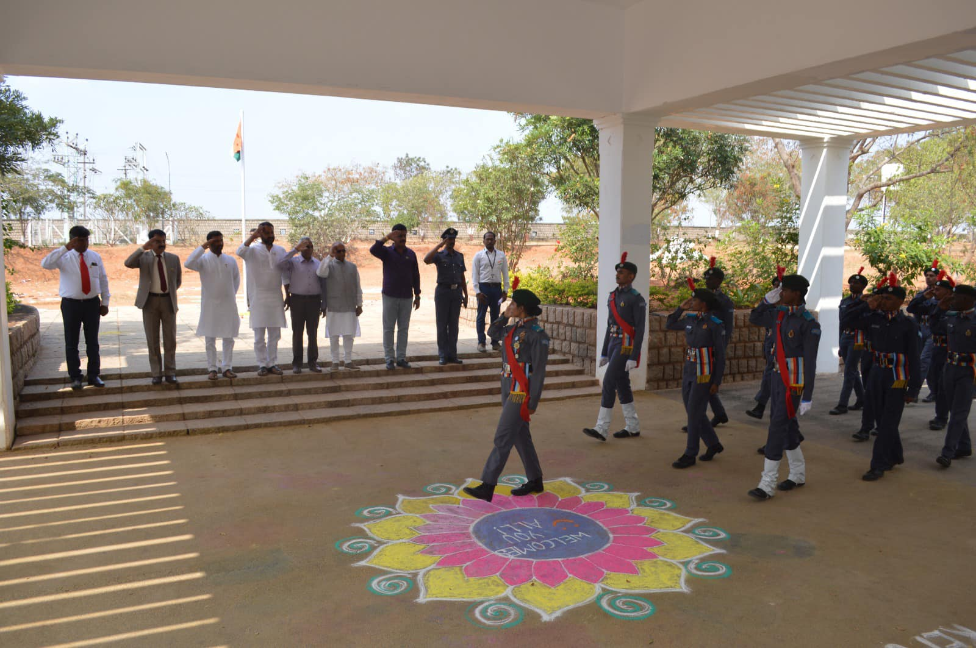TEACHERS DAY
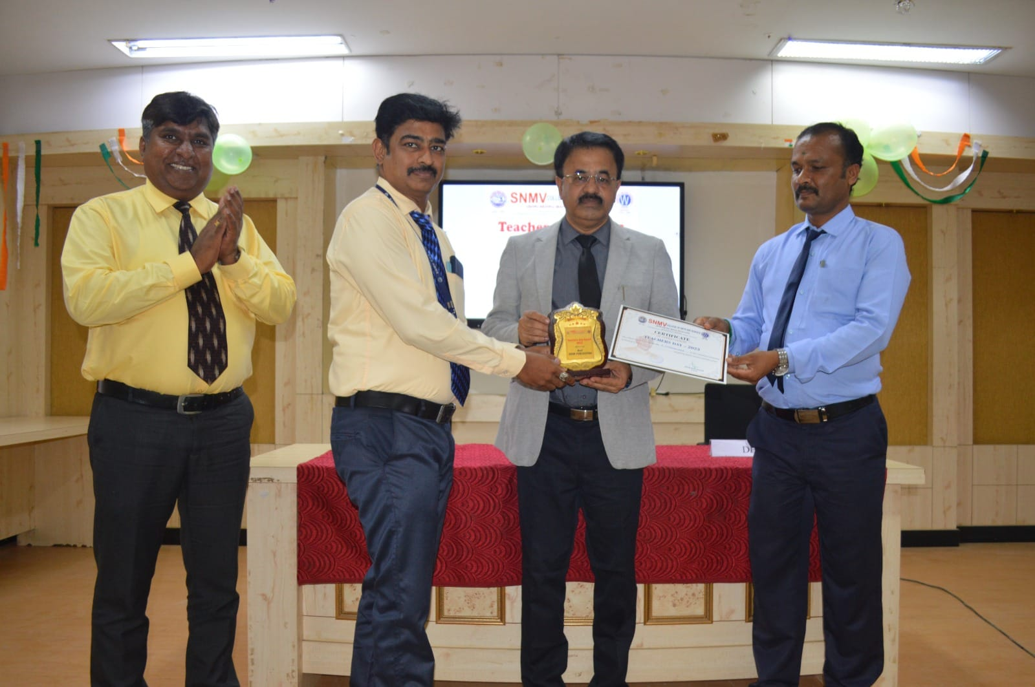
WORLD DAY AGAINST CHILD LABOUR
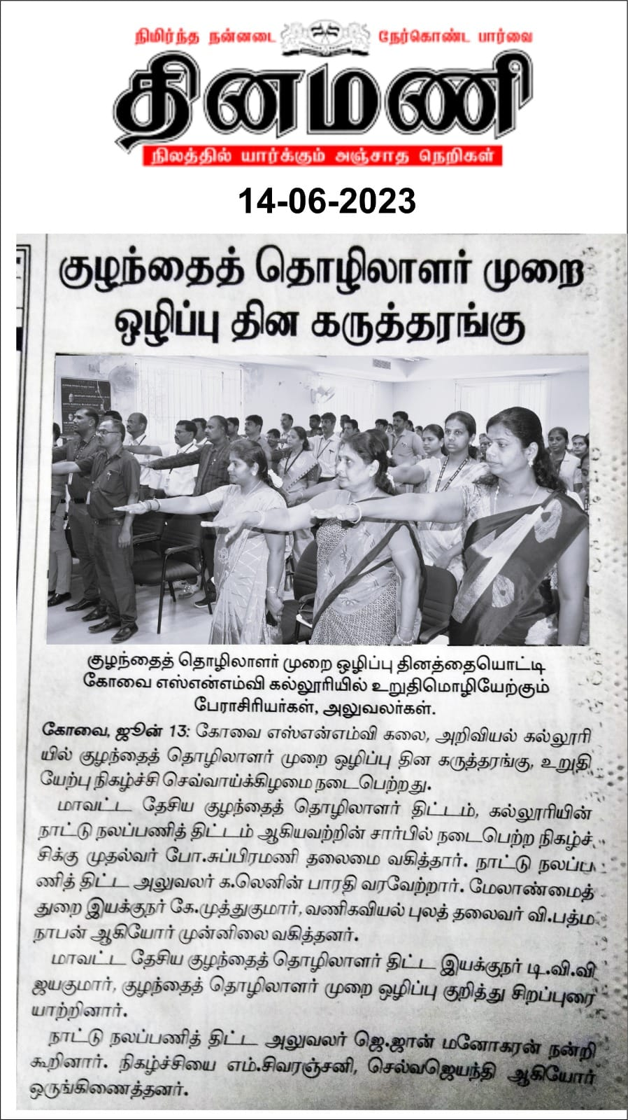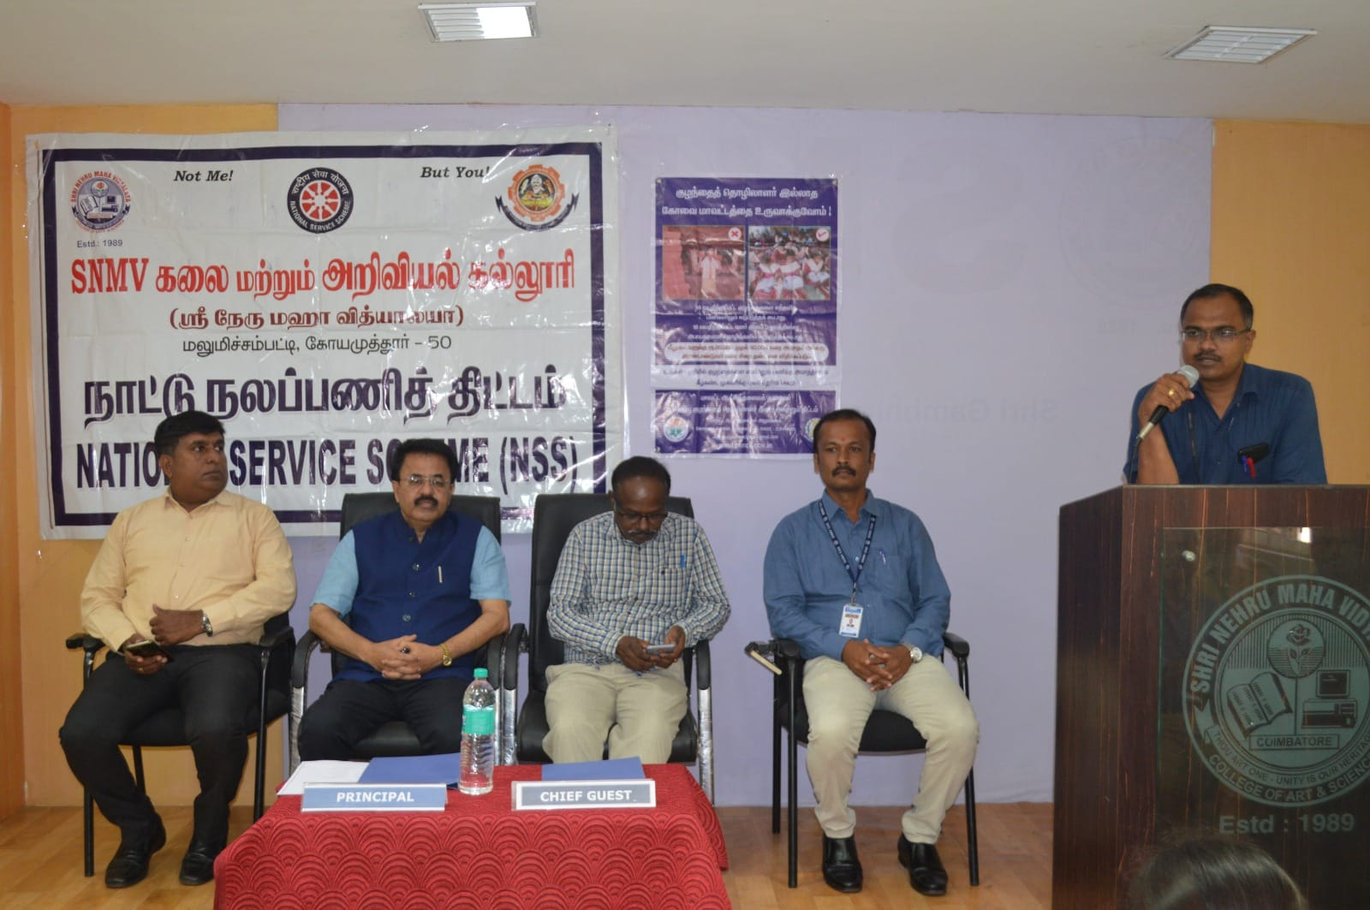

WORLD ENVIRONMENT DAY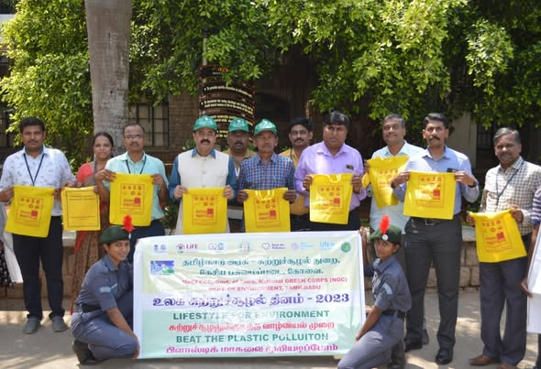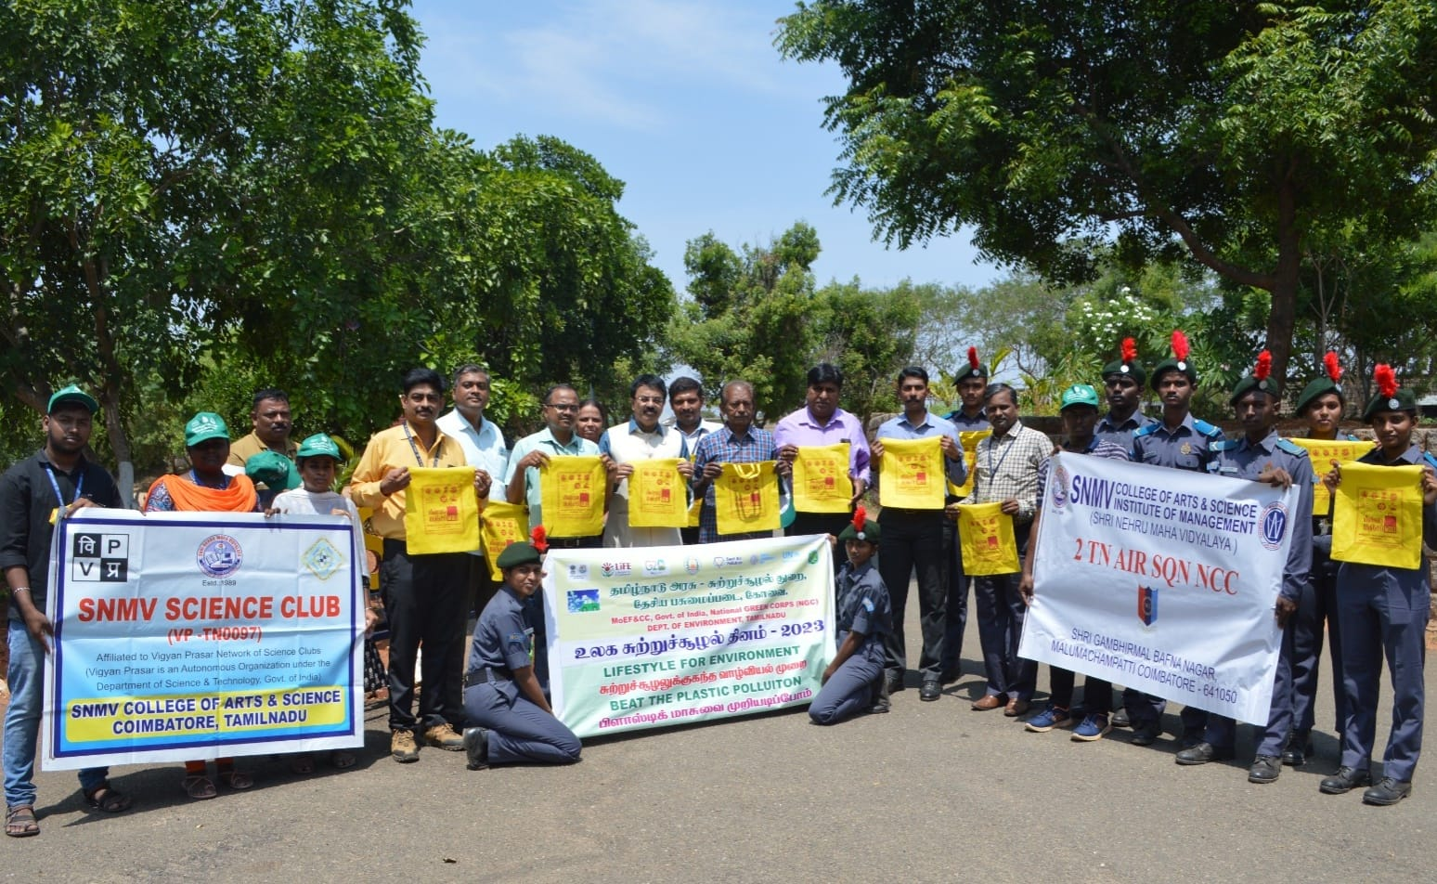

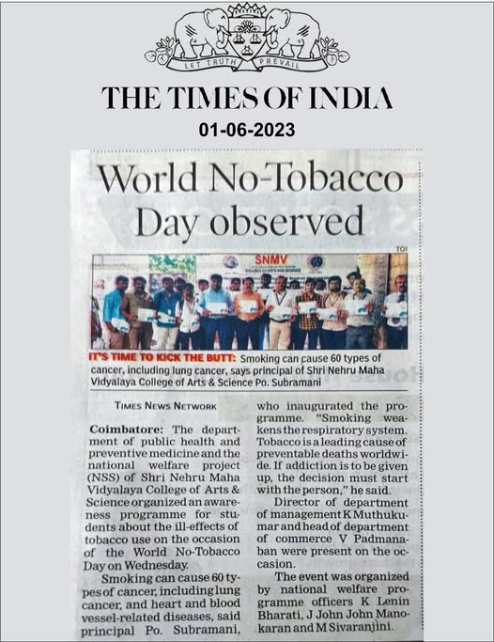
WORLD NO TOBOCCO DAY
ZERO DAY